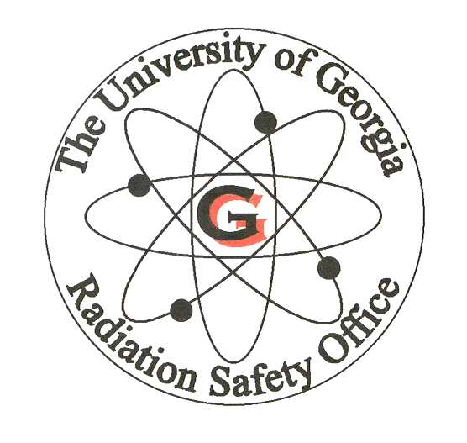
Medical X-Ray Worker Certificate
Initial training for operators of medical x-ray equipment must consist of 6 hours,
and cover the following topics*:
I, the undersigned, have received training in the following subjects/items:

- PROTECTION AGAINST RADIATION
- Protective Clothing
- Patient Holding
- Time, Distance, Shielding
- Radiation Protection Standards: UGA policies and procedures, State and
Federal Regulations, use of dosimetry, use of radiation-detection equipment
5. Biological Effects of Radiation: Effects at various exposure levels, symptoms of acute
exposure, reporting requirements, human case histories

- DARK-ROOM TECHNIQUES
1. Cassettes, Screens, Film Protection, Chemicals: As applicable
2. Operation of Developer

- PATIENT PROTECTION
- Beam Limitation
- Setting Up Techniques: Exam techniques, patient preparation and restraints
- Biological Effects of Radiation: Case histories

- MACHINE SAFETY
- Machine Functions
- Safety Procedures
- Recognizing Problems

Name (printed)___________________________________________________________________

Name (Signature)_______________________________________________ Date _____________

Authorized Supervisor (printed)_________________________________________________
Authorized Supervisor (signature)_____________________________ Date______________

*Rules and Regulations for X-Rays, Chapter 290-5-22, State of Georgia

