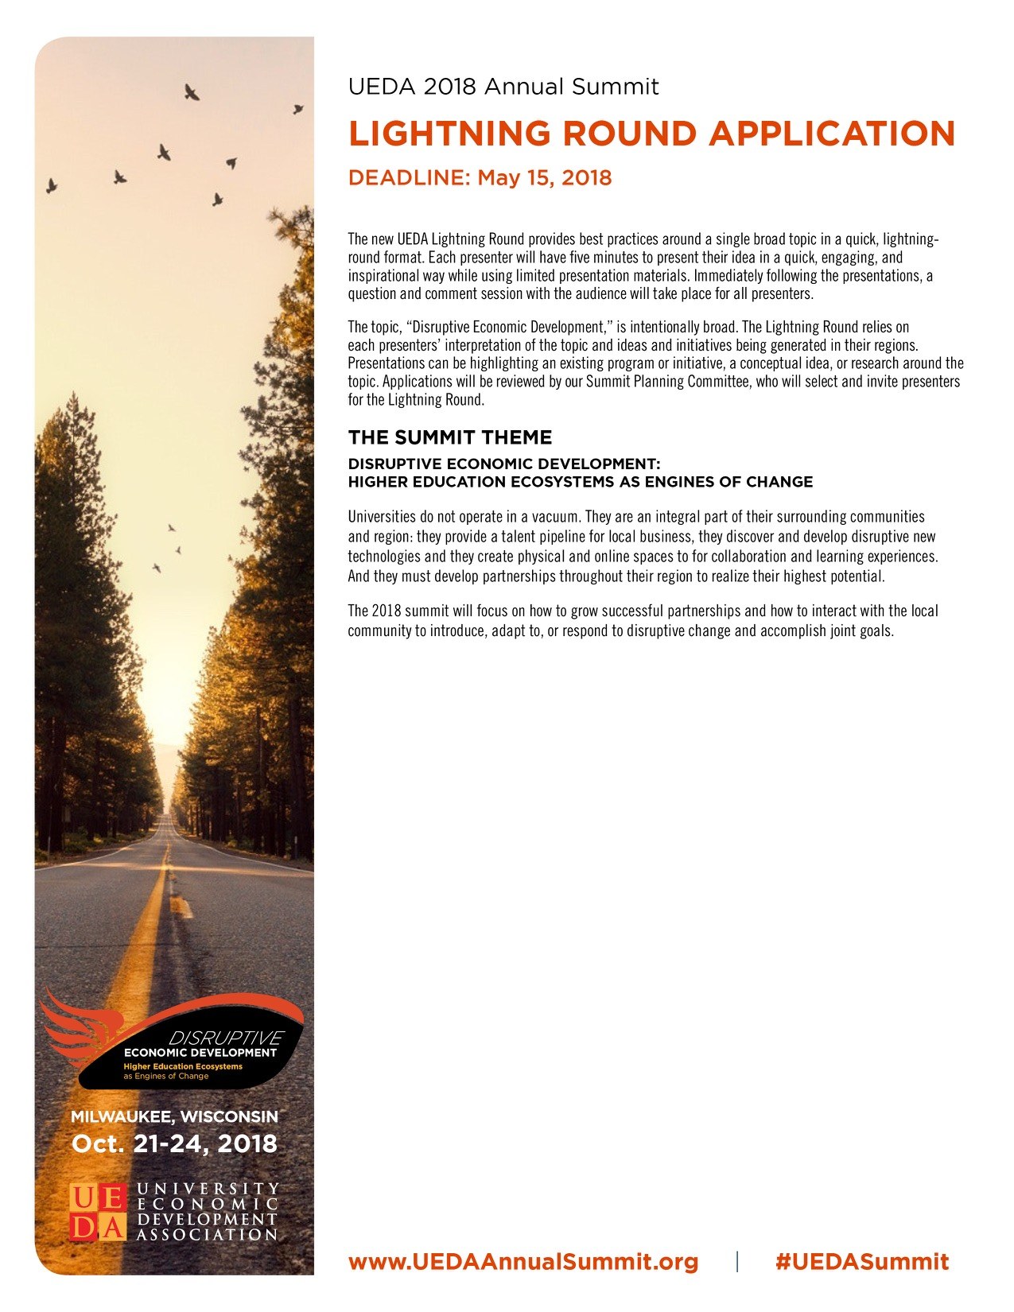
LIGHTNING ROUND APPLICATION
To submit a presentation, complete the information below and resave the file name with the last name of the primary contact person somewhere in that file name. Please keep the proposal in MS Word format. Proposals must be submitted to the UEDA Events Team at events@universityeda.org by May 15, 2018.
The UEDA Annual Summit committee will notify all applicants by June 1, 2018 the status of their proposal. All presentations will be conducted at the UEDA Annual Summit in Milwaukee, Wisconsin October 21 - 24, 2018.

Presenter name:
Presenter title:
Presenter phone:
Presenter email:
Name of organization:

Presentation title:

Presentation abstract:
Limited to 100 words.

Enter abstract here.

How does this presentation relate to the Lightning Round Topic? Limited to 100 words.

Enter relationship to topic here.

Awards of Excellence Participation:
Are you also planning to nominate this topic for a 2018 UEDA Award of Excellence?

Yes No

