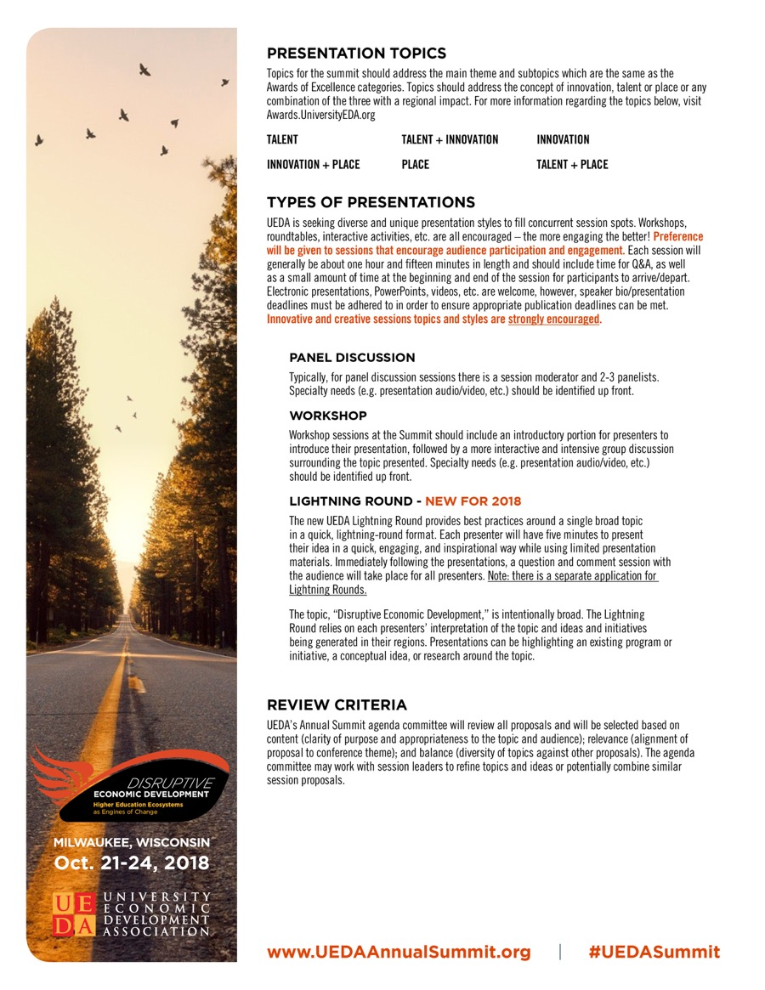
2018 UEDA ANNUAL SUMMIT PRESENTATION PROPOSAL
To submit a presentation, complete the information below and resave the file name with the last name of the primary contact person somewhere in that file name. Please keep the proposal in MS Word format. Proposals must be submitted to the UEDA Events Team at events@universityeda.org by May 15, 2018.
The UEDA Annual Summit committee will notify all applicants by June 1, 2018 the status of their proposal. All presentations will be conducted at the UEDA Annual Summit in Milwaukee, Wisconsin October 21 - 24, 2018. Panelists and moderators will be notified of the final presentation time and day by September 15, 2018.

Topic Areas:
Please rank your presentation’s amount of content in the following areas:

Talent
1 | 2 | 3 | 4 | 5 | 6 | 7 | 8 | 9 | 10
Less |  |  |  |  |  |  |  | More

Innovation
1 | 2 | 3 | 4 | 5 | 6 | 7 | 8 | 9 | 10
Less |  |  |  |  |  |  |  | More

Place
1 | 2 | 3 | 4 | 5 | 6 | 7 | 8 | 9 | 10
Less |  |  |  |  |  |  |  | More

Other (Specify: )

Presentation Format:
Is your presentation a:

Panel Discussion Workshop

Other (Describe: )
Note: Lightning Round Applications are on a separate form.

Awards of Excellence Participation:
Are you also planning to nominate your project for a 2018 UEDA Award of Excellence?

Yes No

Contact Information

Name of Primary Contact:
Title:
Organization/Institution:
Address:
City, State, Zip:
Phone:
Email:

Comments/Notes:

Presentation Information

Title of Presentation:

Abstract of Proposed Session
Limited to 100 words. To be used in the Annual Summit program or on the UEDA website.
Enter abstract here.

What will make this presentation unique?
Limited to 100 words.

Enter unique aspects here.

What is the relevance of this presentation to UEDA members?
Limited to 100 words.

Enter relevance here.

What is the relevance of this presentation to the Summit Theme?
Limited to 100 words.

Enter relevance here.

Presentation Content

Limited to 1,000 words. Include brief description of the overall presentation and/or a description of each panelist’s presentation.

Enter presentation content here.

Presenter Information
Please include name, title, organization, brief bio, phone number, and email address for each presenter.

Enter presenter information here.

