Setting your Browser to Support OVPR’s Adobe PDF Forms

When you click a PDF link on a web page, it can open either within the web browser or directly in Acrobat or Reader. In order to use the forms functions of Adobe Reader, the form must open in Adobe or Acrobat Reader—NOT in the web browser.
Below are some sample forms on the OVPR web site that should open in your Adobe Reader, rather than in your browser using a PDF viewer. When you click on any of these, the document should be displayed in Adobe or Acrobat Reader, not in your web browser:
Cultivar/Germplasm Disclosure
Invention Disclosure
MTA Request for Incoming Materials
MTA Request for Outgoing Materials

Forcing PDF Files to open in Adobe Reader or Adobe Acrobat
The goal of these instructions is to disable the PDF reader/viewer options in your web browser, forcing the PDF forms to be opened by the Adobe Reader installed on your computer so that all the functions of the form set are operational. Each browser has its own settings to control how PDFs open from a web page. To change the display behavior, follow the instructions below for your each of browsers that you may use to access PDF forms.

- Internet Explorer 8 and higher
- Google Chrome
- Mozilla Firefox
- Apple Safari

Internet Explorer 8 and higher
- Open Internet Explorer, and choose Tools > Manage add-ons.
- Under Add-on Types, select Toolbars and Extensions.
- In the Show menu, select All add-ons.
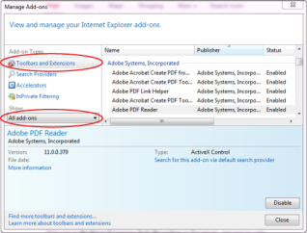
Select All Add-ons from the Show menu in the Manage Add-ons dialog box.
- In the list of add-ons, select Adobe PDF Reader.
Note:
- Click the Disable button (It toggles depending on the status of the selected add-on. If “Enable” is displayed, The Adobe PDF Reader add-on is already Disabled, so do nothing.):
Enable sets the Adobe PDF Reader add-on to open PDFs in the browser.
Disable turns off the add-on so it does not open PDFs in the browser, which is the setting we desire.
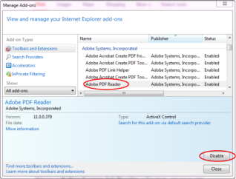
Select Adobe PDF Reader, and click the Disable button.
For more information, see the Internet Explorer help topic Using the Internet Explorer 8 Add-on Manager or How to manage add-ons in Internet Explorer 9.

Google Chrome

- Open Chrome, and go to:
chrome://plugins
- Locate the Chrome PDF plug-in, and, if it is enabled, click Disable.
3. Locate the Adobe PDF plug-in, and if it is enabled, click Disable.

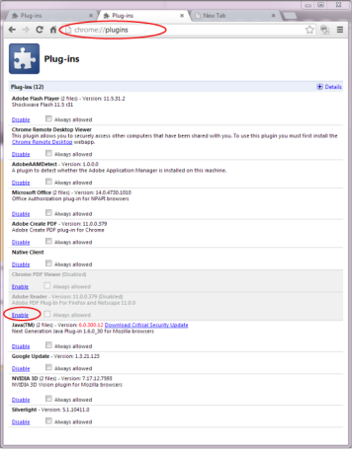
For more information, see the Google Chrome help topic Plug-ins.

Mozilla Firefox
- Choose Tools > Add-ons.
- In the Add-ons Manager window, click the Plugins tab, then select the Acrobat or Reader plugin.
- If Disable button is displayed click on that button and “Enable” will appear. The button toggles depending on the status of the selected add-on.
- If the Enable button is displayed, do nothing. This is the setting we desire.
Enable sets plugin to open PDFs in the browser.
Disable turns off the plugin so it does not open PDFs in the browser, which is the setting we desire.
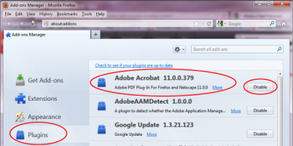
Select the Acrobat or Reader plugin in the Add-ons Manager.
For more information, see the Mozilla Firefox help topic Using a PDF Reader Plug-in.

Apple Safari

Make Acrobat or Reader the default viewer for PDFs
- In the Finder, select a PDF, and choose File > Get Info.
- Click the arrow next to Open With to expose the product menu.
- Choose either Adobe Acrobat or Adobe Reader from the application menu.
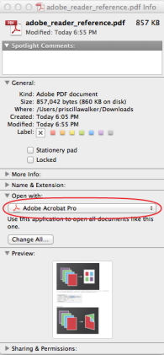
Choose Acrobat or Reader from the application menu.
- Click the Change All button.
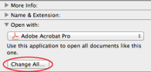
Select Change All in the Open With panel.
- When asked if you want to change all similar documents, click Continue.
Safari browser preferences
- Launch Safari and go to 'Preferences
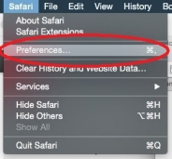
- In the 'Preferences' window click on 'Security' and then click on 'Website Settings' button under 'Internet plug-ins'
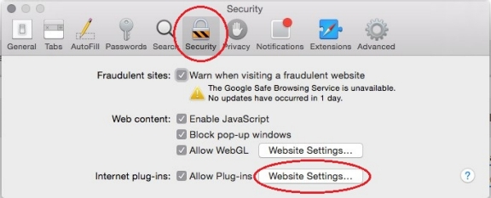
- Now select 'Adobe Reader' in the list of plugins.
Under the option 'When visiting other Websites', in the drop down list select 'Allow Always' and click on 'Done'
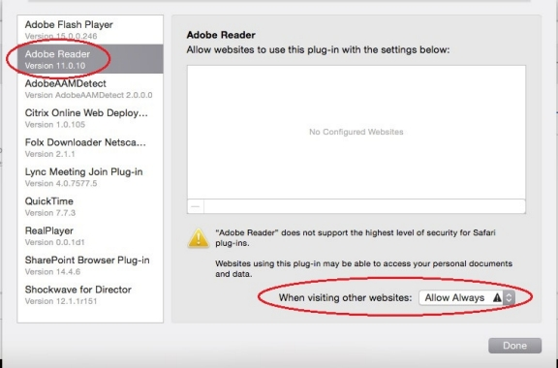
Note:
This will set the browser to use the 'Adobe Reader' plugin to view pdfs

Disable Safari AdobePDFViewer plug-in
You must have root user privileges to change the Safari plug-ins. To display PDFs using the Safari PDF viewer, you must disable the Adobe PDF Viewer.
- Quit Safari.
- Log in as the root user. The root user privileges aren't enabled by default because the root user can change system files. For more information and instructions, see one of the following Apple documents: Enabling and using the "root" user in Mac OS X or OS X Mountain Lion: Enable and disable the root user.
- Choose Go > Go To Folder.
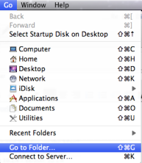
- Type /Library in the Go To The Folder field, and click Go.
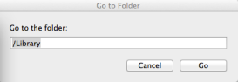
- Create a new folder in the Library folder, and name it Internet Plug-ins Disabled.
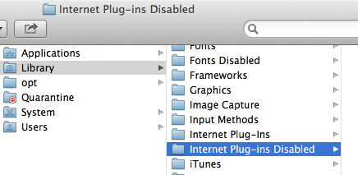
- Open the Internet Plug-ins folder, and move both the AdobePDFViewer.plugin and theAdobePDFViewerNPAPI.plugin into the new Internet Plug-ins Disabled folder.
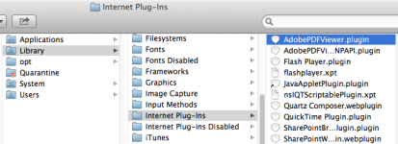
Note:
If both AdobePDFViewer plug-ins are still in the Internet Plug-ins folder, drag them now to the trash. You may be asked for your name and password.
For more information, see the Apple Safari help topic If you need to remove a plug-in.
Choose your region Product

