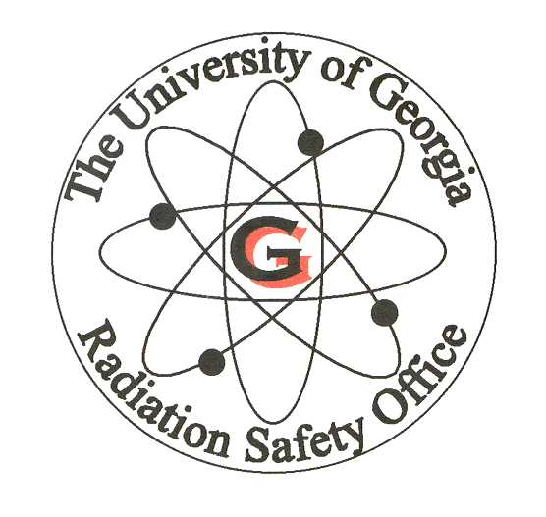
Non-Medical X-Ray Worker Certificate
I, the undersigned, have received training in the following subjects/items:

- X-Ray Equipment Competency

- Identify the hazards associated with your X-ray equipment.
- Understand the significance of warning indicators, safety devices and interlocks.
- Adhere to operating procedures.
- Recognize acute exposure symptoms and how to report these incidences.

- Fundamentals of Radiation Safety

1. Characteristics of radiation
2. Units of radiation measurement
- Significance of radiation dose and exposure (radiation protection standards and biological effects)
- Sources and levels of radiation
- Methods of controlling radiation dose (time, distance, and shielding)

- Radiation Detection Instrumentation to be Used

- Use of radiation survey instruments (operation, calibration, limitations)
- Use of personnel monitoring equipment (dosimetry)

- Radiographic Equipment to be Used

- Remote handling equipment
- Radiographic exposure devices and sealed sources
- Operation and control of x-ray equipment

- Pertinent Federal and State Regulations
- The Registered Users Written Operating and Emergency Procedures
- Case Histories of Radiography Accidents

Name (printed)

Name (signature) Date

Principal Investigator (printed)

Principal Investigator (signature) Date

